EXPERIMENT – 7:
CONTINUOUS-TIME FOURIER TRANSFORM AND SPECTRUM

OBJECTIVES :
(ii) To determine the magnitude and phase spectra of continuous-time signals and analyze their significant spectral components.
(iii) To verify important Fourier transform properties and examine their effects on the corresponding time-domain and frequency-domain representations.

MATLAB CODING :
clc; clear; close all;
%% 7(ii) Determination of Magnitude and Phase Spectra of Continuous-Time Signals
figure;
% Magnitude and Phase Spectrum of a CT Signal
t = -2:0.001:2;
dt = t(2)-t(1);
x = exp(-t.^2).*cos(2*pi*3*t);
N = 4096;
X = fftshift(fft(x,N))*dt;
f = (-N/2:N/2-1)/(N*dt);
magX = abs(X);
phaseX = unwrap(angle(X));
subplot(3,1,1);
plot(t,x); grid on;
xlabel('Time (s)'); ylabel('Amplitude');
title('Continuous-Time Signal');
subplot(3,1,2);
plot(f,magX); xlim([-10 10]); grid on;
xlabel('Frequency (Hz)'); ylabel('|X(f)|');
title('Magnitude Spectrum');
subplot(3,1,3);
plot(f,phaseX); xlim([-10 10]); grid on;
xlabel('Frequency (Hz)'); ylabel('Phase (rad)');
title('Phase Spectrum');

OUTPUT :
To determine the magnitude and phase spectra of continuous-time signals and analyze their significant spectral components.
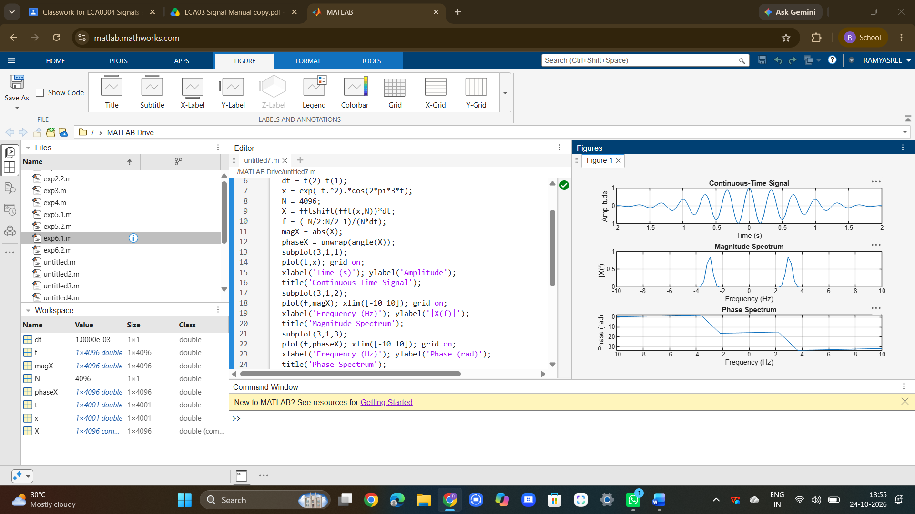

To verify important Fourier transform properties and examine their effects on the corresponding time-domain and frequency-domain representations.
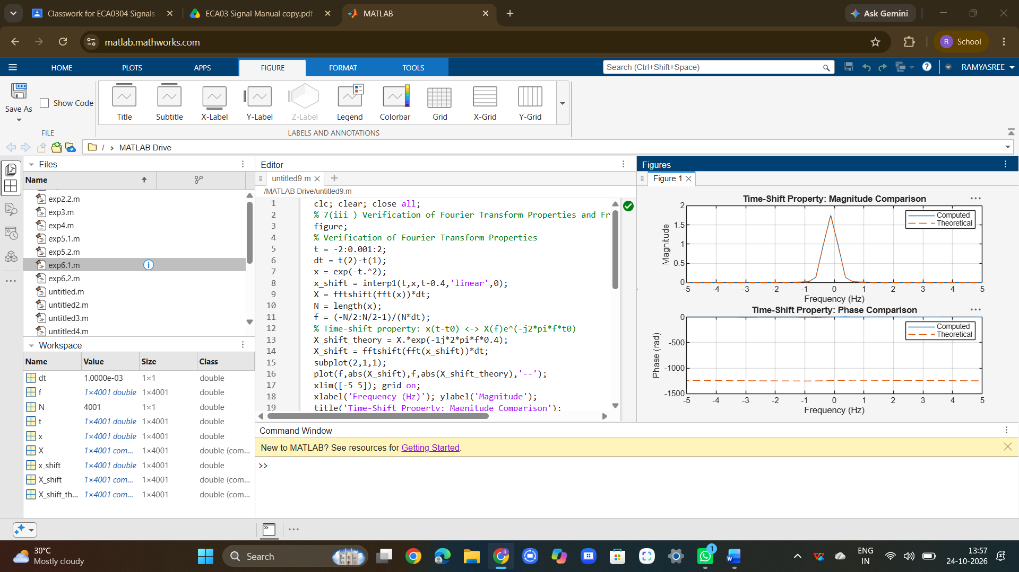

RESULT :
The continuous-time Fourier transform of representative signals was successfully obtained using FFT-based approximation, and their magnitude and phase spectra were analyzed to identify significant frequency components. The time-shift property was verified by comparing the computed and theoretical Fourier transforms, confirming that time shifting preserves magnitude while introducing a frequency-dependent phase shift. The spectral components and occupied bandwidth of a composite communication signal were also determined, demonstrating the importance of frequency-domain analysis in communication-system design.

